SAMPLE TEXT: Final_Final_REAL
Description | It is 2013. The bass is clipping, the chips are everywhere, and your friend's "final final REAL" montage still ends with SAMPLE TEXT.  They swear the finished endcard was in this project before the crash. The recovered workspace opens, the frag reel plays, and the upload is due tonight. Put the ending back together and recover the reward printed on it.
Files | Category: Steganography / Forensics  Difficulty: Medium  Run the static editor from this challenge folder:  docker compose -f challenge/compose.yaml up --build -d  Open http://localhost:18114 in a current desktop Chromium or Firefox browser. The application includes the project, media, PNG inspection tools and frame export. Edits stay in the current browser; File → Save project as… downloads a reusable recovery project.  The same player evidence is available as recovered-project.zip, also downloadable from Project archive in the editor. It contains six original PNG overlays, the recovery-project JSON, the frag reel, soundtrack, format reference and media credits. This is a recovery interchange file, not a native Vegas .veg project. The editor serves only challenge/public/.
Hint(s) | None.
Walkthrough | The pictures contain more information than their ordinary previews show. Each PNG has an invisible region whose RGB channels hold a piece of an illustrated endcard. Reveal those color channels, then repair each endcard event's crop, orientation and placement. The artwork's continuous outlines and interrupted lettering show how the pieces join.  1. Play the frag reel, then use Endcard ▸ to reach the last four seconds. Select a picture in Project Media. The small meme image occupies only a fraction of its listed 1024 × 768 source size. Media Properties also shows that the same file supplies both an earlier montage event and an endcard event.  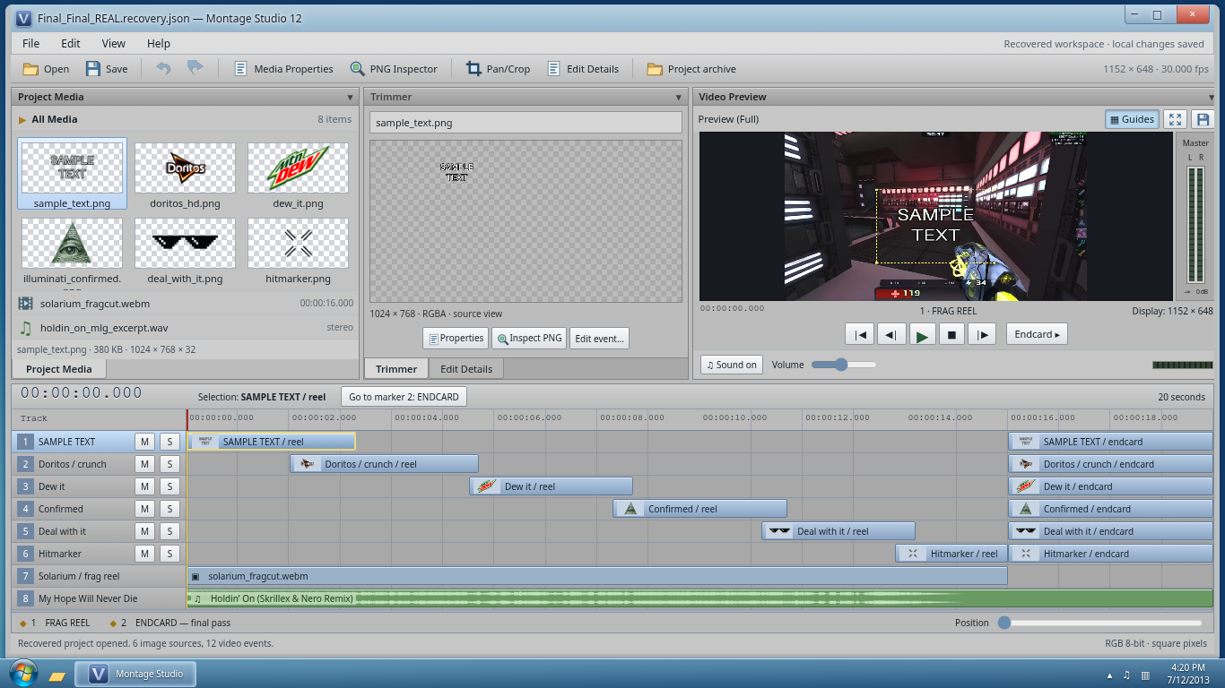  2. Open PNG Inspector. Move over the apparently empty margins. Some stored pixels have changing red, green and blue values even though A = 0. Alpha controls visibility; zero alpha does not require the stored RGB channels to be zero. Choose RGB (ignore alpha). A piece of a detailed illustration appears in the margin. Inspection alone does not change the project.  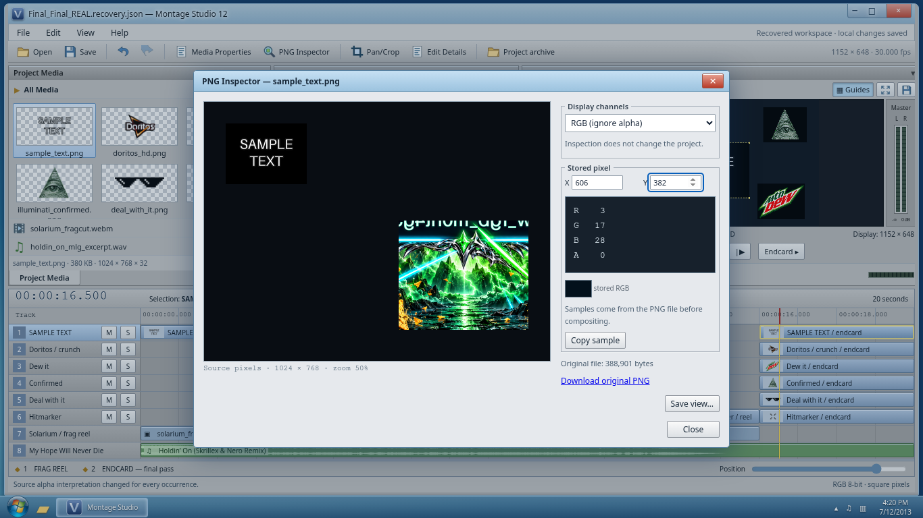  3. Close the inspector. Choose Edit Details to show the event controls. Change Alpha channel to None (ignore alpha) in the event controls or Media Properties. The source now displays its stored RGB, but the timeline still shows the old meme crop. This is the source/event distinction: changing media interpretation does not remove an event's crop or mirroring.  4. Open Pan/Crop… for the selected endcard event. Drag the crop rectangle over the illustrated fragment, or enter its source coordinates. The fragment boundaries are visible against the plain surrounding pixels. Use Apply, then Use crop size under Track Motion to display the recovered piece at its original dimensions.  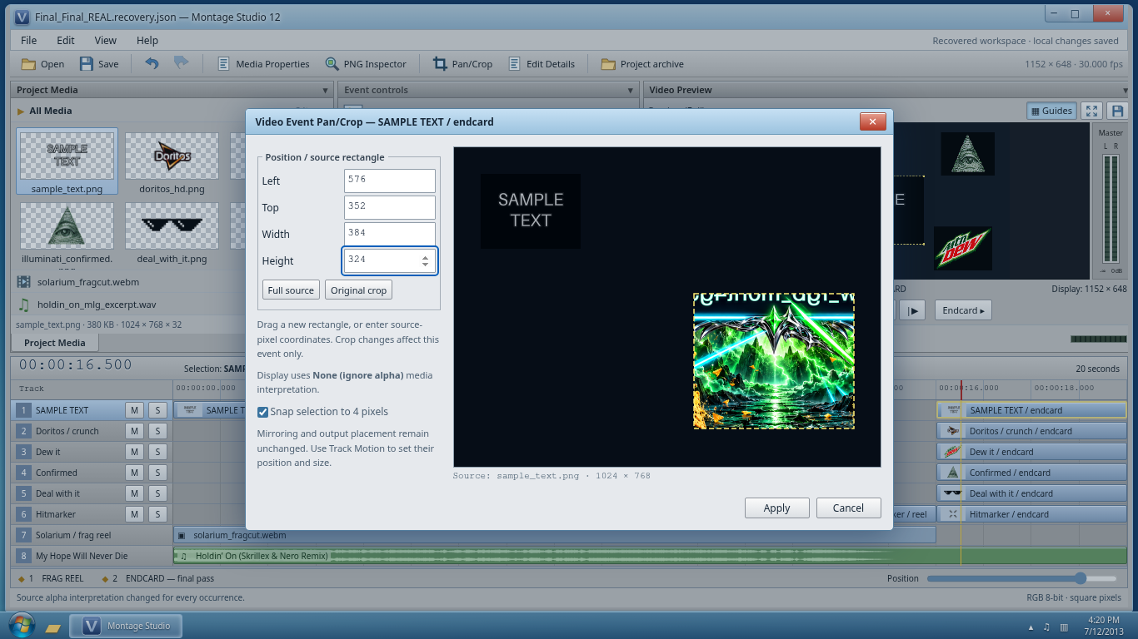  5. Repeat for the six endcard events. Each fragment is 384 × 324. Mirror pieces where necessary, using the artwork's orientation and matching edges. Drag them in Video Preview, or enter Left and Top under Track Motion. Some earlier montage mirroring is inappropriate for the ending. The continuous cyan frame, chrome ornaments, speaker, pyramid and soda can identify neighboring pieces. All flag lettering crosses the middle seam, so the upper and lower fragments need to meet.  The completed arrangement is:  Set Width = 384 and Height = 324 for both the crop and output placement of every piece. Keep the six endcard events visible and clear Solo.  6. Turn Guides off and open the larger Video Preview. The endcard's central line contains the actual flag. Save snapshot… exports the current composition as a real PNG; it does not replace the frame with a prepared answer. Save the recovery project to keep the edits as well.  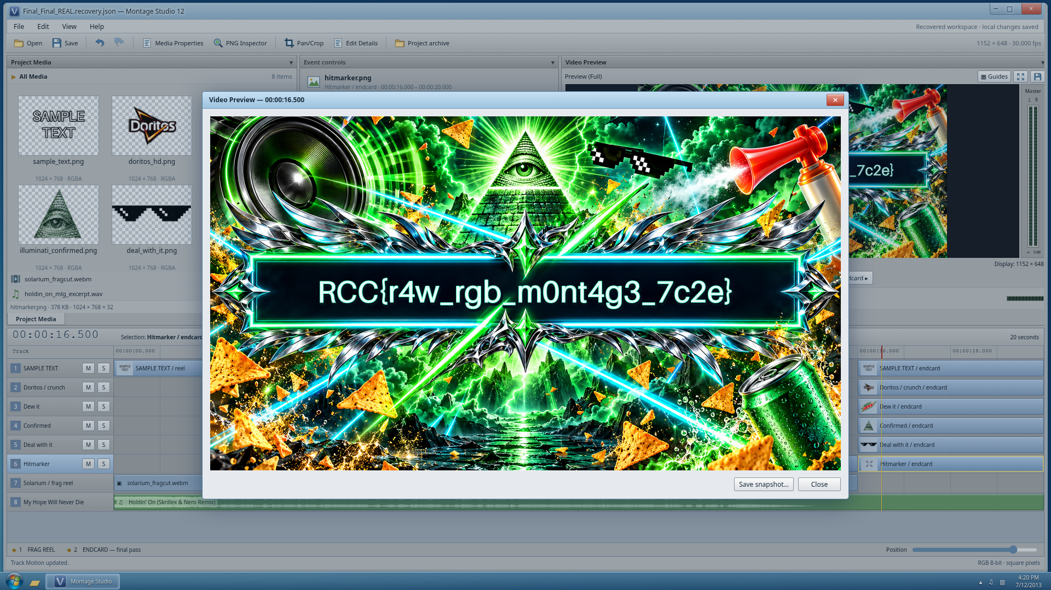  The external route uses the same evidence. Extract the archive and inspect a PNG with Pillow, which retains the independent RGBA samples:  from PIL import Image  image = Image.open("media/sample_text.png").convert("RGBA")  print(image.getpixel((606, 382))) # Nonzero RGB, alpha 0  image.putalpha(255)  image.save("sample_text-rgb.png")  Repeat for the other sources. Crop the visible illustrated rectangles and arrange them in an image editor using the same visual joins. For example, the SAMPLE TEXT fragment is image.crop((576, 352, 960, 676)); flip it horizontally, then place it at (384, 324) in a 1152 × 648 image. The table above describes the remaining pieces. The distributed format reference explains source coordinates and output coordinates for anyone recreating the composition in a script.
  Source | Crop Left, Top | Mirror X | Mirror Y | Output Left, Top
  doritos_hd.png | 352, 400 | Off | On | 0, 0
  deal_with_it.png | 384, 368 | Off | Off | 384, 0
  illuminati_confirmed.png | 608, 384 | Off | On | 768, 0
  hitmarker.png | 512, 416 | On | Off | 0, 324
  sample_text.png | 576, 352 | On | Off | 384, 324
  dew_it.png | 448, 320 | On | Off | 768, 324
Flag | RCC{r4w_rgb_m0nt4g3_7c2e}

